**PIZZA SALES SQL QUERIES**

1. **KPI’s**
2. **Total Revenue:**

**Select sum (total_price) as Total_Revenue from pizza_sale;**

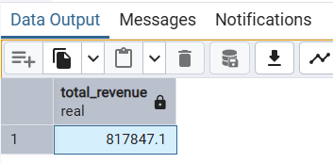

1. **Average Order Value:**

**select sum(total_price)/ count (distinct order_id) as Avg_Order_Value from pizza_sale;**

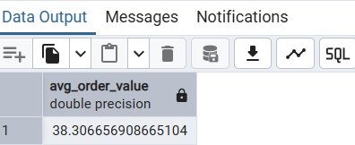

1. **Total Pizza Sold**

**select sum(quantity) as Total_pizza_sold from pizza_sale;**

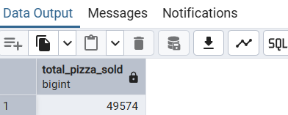

1. **Total order**

**select count(distinct order_id) as total_order from pizza_sale;**

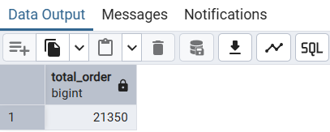

1. **Average Pizzas Sale Per Order**

**select CAST (CAST (sum(quantity) as DECIMAL (10,2)) /**

**CAST (count (distinct order_id) as DECIMAL (10,2)) AS DECIMAL (10,2)) as avg_pizza_per_order from pizza_sale;**

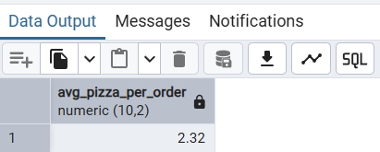

1. **Percentage of sales by pizzas category**

**select pizza_category, sum(quantity) as Total_pizza_sold**

**from pizza_sale**

**group by pizza_category**

**order by pizza_category;**

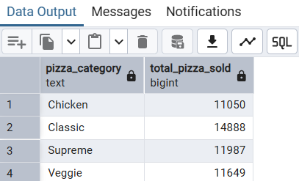

1. **Hourly Trends for Total Pizzas**

**SELECT EXTRACT (HOUR FROM order_time) AS order_time,**

**COUNT (DISTINCT order_id) AS Total_order**

**FROM pizza_sale**

**GROUP BY EXTRACT (HOUR FROM order_time)**

**ORDER BY order_time;**

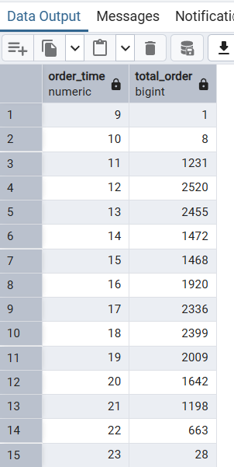

**D. Percentage sales by category**

**select pizza_category, sum(total_price) as total_sales, CAST (sum(total_price) * 100/**

**(select sum(total_price) from pizza_sale) AS DECIMAL (10,2)) as Percentage_sale_by_category**

**from pizza_sale**

**group by pizza_category**

**order by Percentage_sale_by_category desc;**

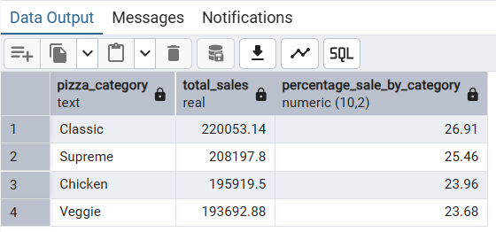

1. **Percentage of pizzas sales by size**

**select pizza_size, sum(total_price) as total_sales, CAST(sum(total_price) * 100/**

**(select sum(total_price) from pizza_sale) AS DECIMAL (10,2)) as Percentage_sale_by_size**

**from pizza_sale**

**group by pizza_size**

**order by Percentage_sale_by_size desc;**

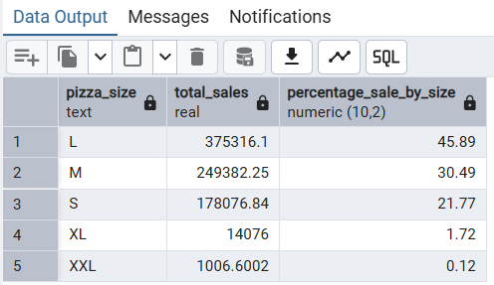

**F. Top 5 Pizzas sold there’s names:**

**select pizza_name, sum(quantity) as Total_pizzas_sold**

**from pizza_sale**

**group by pizza_name**

**order by sum(quantity) desc**

**limit 5;**

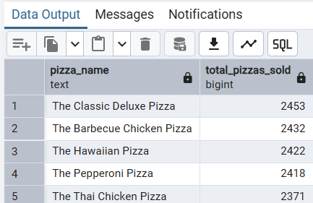

1. **Bottom 5 pizzas sold there’s names :**

**select pizza_name, sum(quantity) as Toatl_pizzas_sold**

**from pizza_sale**

**group by pizza_name**

**order by sum(quantity)**

**limit 5;**

